**Pharmacokinetic data analysis**

Lopinavir is used in the treatment of HIV, by different types of populations. Doctors would like to know whether the elimination rate constant of this drug is different in pregnant and non-pregnant women, and whether it makes a difference whether these woman are older or younger than 35 years of age. This is because clearance is an important determinant for drug dosing. They have concentration – time data available from different patients that all received a dose of 400 mg lopinavir.

**Question 1)**

You have received an excel file “*Lopinavir_Pregnancy.xlsx.*” which contains all relevant information in different sheet. Read in all data in R and describe the design of the study.

**Question 2)**

The software that you are going to use to analyze the data needs the format to be as indicated below.

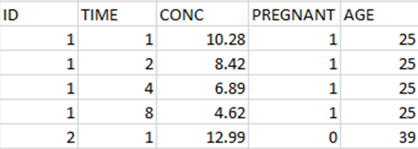

Write a script that takes the original data and changes it into the format of the example.

**Question 3)**

Plot the concentration-time data for all patients and use different colors for pregnant and non-pregnant women and different line types for women older and younger than 35. Do this on a linear scale and semi-logarithmic scale

**Question 4)**

The concentration-time data reveals a linear profile on a semi-logarithmic scale. To be able to perform a linear regression add a new column to the dataset that contains the LN-values of the concentrations.

**Question 5)**

Fit a linear model to the ln-transformed concentration values of both treatment arms. The peak concentration is mainly determined by the distribution volume of lopinavir, while the slope of the profiles is mainly determined by the elimination rate constant. Do you anticipate differences in elimination rate constants between pregnant and non-pregnant women? And between woman older and younger than 35 years.

**Question 6)**

Fit a linear model to the ln-transformed concentration values of all individual patients in all four patient types (pregnant & younger than 35 years, pregnant & older than 35 years, non-pregnant & younger than 35 years, non-pregnant & older than 35 years) and make a table that includes ID number, patient type, and the slope of the linear fit. This slope represents the elimination rate constant of lopinavir.

**Question 7)**

Perform an ANOVA analysis and provide an interpretation of the results regarding the research question of whether the elimination rate constant of lopinavir is statistically significantly different in the four patient types.